Generative AI Disclosure

Section 1. AI Usage and Purpose

ChatGPT was used to clearly format the AI disclosure and to implement my code to meet all the requirements. The initial implementation was done by my hand to follow exact C++ format mentioned in the direction and possible test cases. Then, AI was used to develop any unknown edge cases I might have missed in the development stage and for clear format of AI disclosure. All the AI usage mentioned below was done on September 27, 2026.

Section 2. AI Prompt and Response

After the initial implementation of IPv4 address extraction program, I used the GPT-5.6 Luna version of ChatGPT to implement test cases and to develop tricky edge cases to identify possible errors.
I have prompted with my uploaded source code: “Here is my code and I want to double check test cases covers the requirement and corner cases. Look for any missing requirements from the code. Here are the requirements:

Built-in functions/libraries you may not use
- Any string-to-number conversion function: atoi, atol, atoll, strtol, strtoul, strtod, stoi, stol, stoul, sscanf, scanf with numeric conversions.
- Any address-parsing library function: inet_aton, inet_pton, inet_addr, or equivalents.
- Any regular-expression facility (std::regex, POSIX regex.h, or similar) — the parsing and validation logic must be your own character-by-character code, not a pattern matched by a library.
- Standard character-classification functions (isdigit, etc.) are fine to use.

Other requirements
- Exactly one valid address may be extracted per input line; everything else in the line is either garbage (skipped) or part of a candidate token that fails validation.
- Reject anything that does not exactly match the grammar above — wrong octet count, empty octet, out-of-range octet or port, a disallowed leading zero, a second colon, a colon not immediately after the fourth octet, or a stray period/colon directly adjacent to an otherwise-valid address.
- On success, print: Extracted IPv4 address: A.B.C.D (decimal value: N, port: P) where N is the 32-bit decimal value and P is the port number or the literal text none. ” (The requirements are directly copied and pasted from the Canvas)
AI walked through my test cases testing the normal IPv4 addresses, addresses embedded in text, valid ports, invalid ports, leading zeros, and several malformed addresses. However, there was a partial-match problem that has been detected.
For example, when testing: 999.1.1.1 the parser rejected 999 because an IPv4 octet cannot exceed 255, but it could then continue scanning from inside the same malformed token and identify: 99.1.1.1 as a valid address. Similarly, an input such as: 1234.1.2.3 could cause the parser to find 234.1.2.3 inside the invalid first octet.
This violated the assignment requirement that the parser must not find a valid partial match inside a longer malformed candidate.
I corrected the candidate-start logic so that a new IPv4 candidate can begin with a digit only if the previous character is not another digit, a period, or a colon. This prevents the parser from starting a new candidate in the middle of a malformed numeric or punctuation sequence.
After the correction: 999.1.1.1 is rejected completely, while: 192a168.1.1.1 still correctly extracts: 168.1.1.1
Corrected part of my code in 20-34:
if (!isdigit(static_cast<unsigned char>(str[i])) ||
(i > 0 &&
(isdigit(static_cast<unsigned char>(str[i - 1])) ||
str[i - 1] == '.' ||
str[i - 1] == ':')))
{
i++;
continue;
}
The initial test cases covered several categories in same order of normal valid addresses, valid ports and port boundaries, invalid ports, invalid octets, invalid structure, and embedded addresses. Though, I had to add new test cases for partial match problems from test_cases.txt line 53-57:
999.1.1.1
1234.1.2.3
1.2345.2.3 1.2.3.456
1000.2.3.4
To write the AI closure statement, I asked how to format the AI closure requirement should be. The prompt was asked to same version of ChatGPT: “Here are the requirements for the AI disclosure and how should I format the disclosure.

General disclosure
- Clearly state which GAI tool was used (e.g., ChatGPT, Copilot, Gemini, etc.), and specify the version if known (e.g., GPT-4, Claude 3.5).
- Indicate the date(s) the tool was consulted.

Code attribution
- Copy the exact prompt(s) you used to generate the code.
- Document which parts of the code were AI-generated versus student-written.
- Note any modifications you made to the AI-generated output, and why.

Verification statement
- Confirm that you understand every line of the submitted code — no blind copying.
- State that the code has been tested and works as intended.
- Acknowledge any known bugs, limitations, or unexpected behavior you did not resolve.”

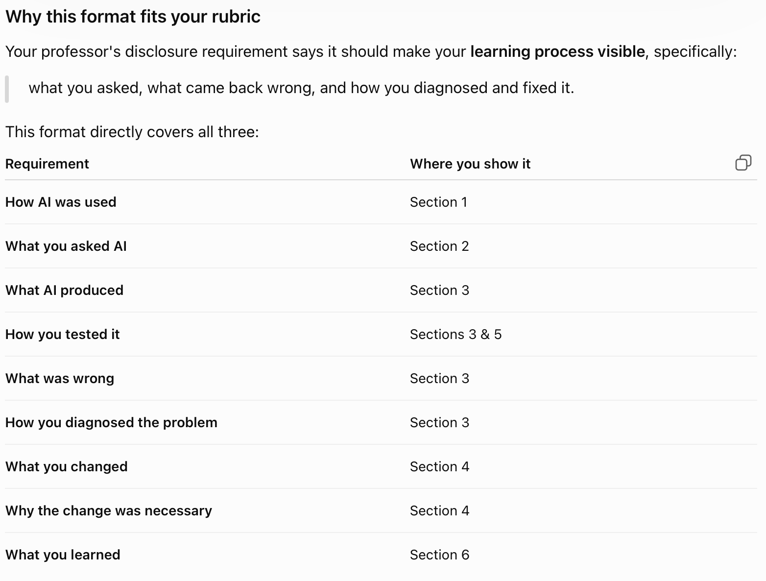

With the summarized format, I have modified the given AI disclosure format after reviewing all the requirements again.

Section 3. Verification Statement
All prompts are recorded on section 2. All AI responses are reviewed and partially used with clear mentioned or commented. I have tested the program using normal valid addresses, addresses embedded in text, boundary values, invalid octets, invalid ports, leading zeros, malformed addresses, extra periods and colons, and partial-match cases. I also tested the correction made after discovering the partial-match problem. I have understood the possible error for partial-match and correction made to the code to avoid error.

Section 4. Reflection
I used additional test cases found by AI and then modified the candidate-start logic so that the program could not begin a new IPv4 candidate in the middle of a numeric or punctuation sequence. I also expanded my test cases after finding this problem to make sure the correction did not cause other errors like preventing legitimate addresses separated by garbage characters from being detected.
From this assignment, I learned the proper usage of AI and how to write clear AI disclosure. I learned that I need to understand the requirements, examine the generated code that may contain error, create tests based on those requirements, and verify the behavior instead of assuming that generated code is correct.

